LED hand controller project

- Purpose :
The purpose of our project is to control the sequence of lighting of five LEDS by our hands through computer vision in which by raising the pointer finger to the camera one LED will be turned on and if we put number two on our fingers to the camera two LEDS will be turned ON and if we put number three on our fingers to the camera 3 LEDS will be turned ON and so on.. till number five, it’s going to be operated by real-time and machine learning interfaces.
Our project is divided into two sections which are:

- Hardware (Electronic components):
- Arduino Uno controller.
- Breadboard.
- 5 LEDS with different colors.
- 5 Resistors of 220 ohm.

- Software (Coding and Programming):
- Arduino IDE.
- Python on Visual studio.

- So let’s start with the easy part which is the Hardware connection

- Hardware:

- First we put an Arduino controller and a Breadboard next to each other in which we can connect the GND pin of arduino with the negative pole of breadboard.

- Then we get 5 LEDS of different colors and put them as the following:
LEDS | Position on breadboard | Cathode connection | Anode connection
LED1 (Green). | Pins: 6 and 7. | Connect with negative pole on breadboard. | Connect with a 220 ohm resistor.
LED2 (Orange) | Pins: 11 and 12. | Connect with negative pole on breadboard. | Connect with a 220 ohm resistor.
LED3 (Blue). | Pins: 16 and 17. | Connect with negative pole on breadboard. | Connect with a 220 ohm resistor.
LED4 (Red). | Pins: 21 and 22. | Connect with negative pole on breadboard. | Connect with a 220 ohm resistor.
LED5 (White). | Pins: 26 and 27. | Connect with negative pole on breadboard. | Connect with a 220 ohm resistor.
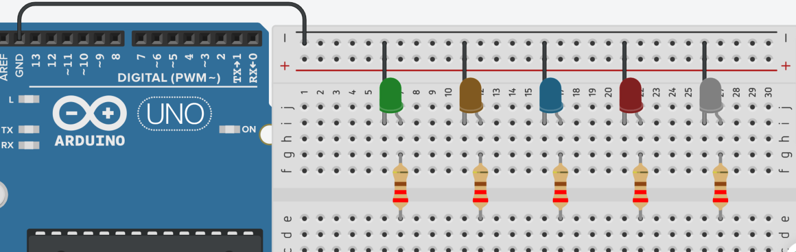

Resistors | Position on breadboard | First terminal  connection | Second terminal connection
R1 of LED 1 (Green) | PINS: g and e | LED 1 Anode | Pin 1 on arduino
R2 of LED 2 (Orange) | PINS: g and e | LED 2 Anode | Pin 2 on arduino
R3 of LED 3 (Blue) | PINS: g and e | LED 3 Anode | Pin 3 on arduino
R4 of LED 4 (Red) | PINS: g and e | LED 3 Anode | Pin 4 on arduino
R5 of LED 5 (White) | PINS: g and e | LED 4 Anode | Pin 5 on arduino
- Get 5 Resistors of 220 ohm and connect them as the following:

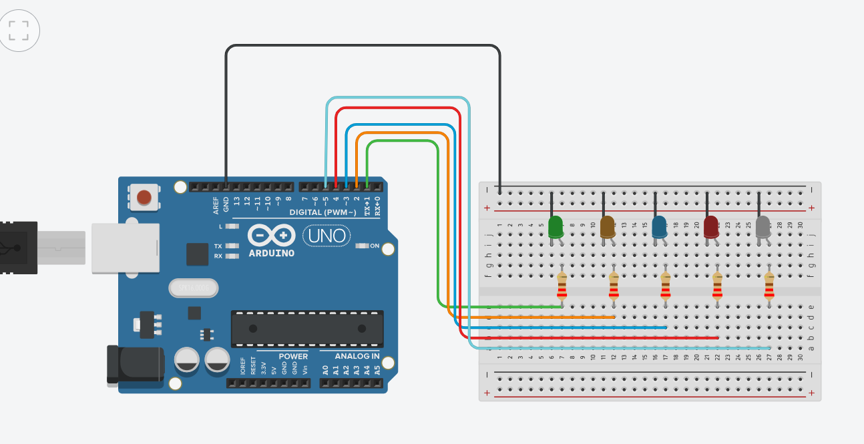

- Now it’s time for coding and programming in which all of the work begin.

- Software:
- Python:

- Our code is mainly written with python because it’s one of the best programming languages that can deal with camera vision real-time applications as it has a lot of modules and libraries that can serve our projects as we need it to be.

- But before jumping into the code there are some terms that need to be defined first :

- Module: The module is a simple Python file that contains collections of functions and global variables and with having a .py extension file. It is an executable file and to organize all the modules we have the concept called Package in Python.

- Package: The package is a simple directory having collections of modules. This directory contains Python modules and also having __init__.py file by which the interpreter interprets it as a Package. The package is simply a namespace. The package also contains sub-packages inside it.

- Library: The library is having a collection of related functionality of codes that allows you to perform many tasks without writing your code. It is a reusable chunk of code that we can use by importing it into our program, we can just use it by importing that library and calling the method of that library with a period(.). However, it is often assumed that while a package is a collection of modules, a library is a collection of packages.

- So let’s start the code by knowing the libraries, Modules and Packages that we’re going to use and how we can install it:

External file | Type | Function | Installation | Syntax in python file
PIP  NOTE: If your python version is 3.4 or above so pip package is already installed | Package | It’s used to install and manage software packages written in python. | - Download get_pip.py.  - Open command prompt.  - Run the installation syntax. | get _pip.py
NUMPY | Library | It’s used to deal with multidimensional arrays. | - Open command prompt.  - Type “pip install numpy”  - Click enter  - Wait till until it’s done. | import numpy
Opencv | Library | It’s used to deal with real-time computer vision. | - Open command prompt.  - Type “ pip install opencv-python”  - Click enter  - Wait until done | import cv2
mediapipe | Library | It’s an open source for machine learning and computer vision libraries | - Open command prompt.  - Type “ pip install mediapipe”  - Click enter  - Wait until done | Import mediapipe as mp

- Now let’s start in our code:

